Assembling the Stack DIY sku 5201
Electronics assembly
 | 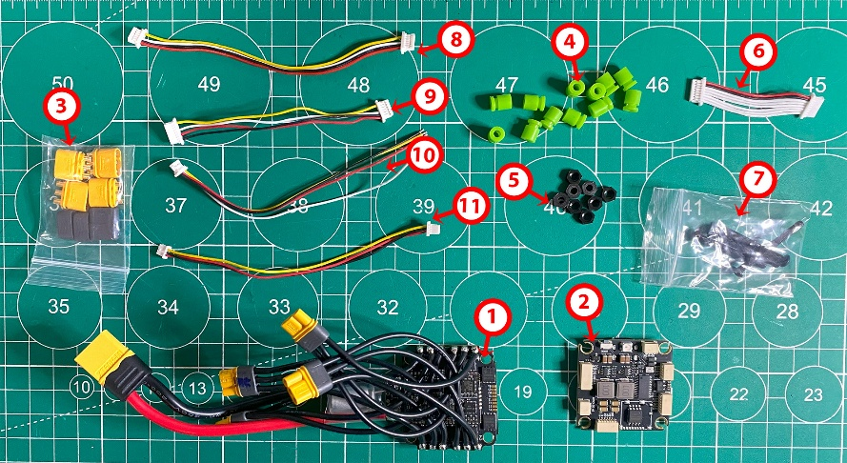 | Package: Stack DIY Kit  (f405 V3 Fc+ 60A v1 ESC)  Sku: 5201
 | 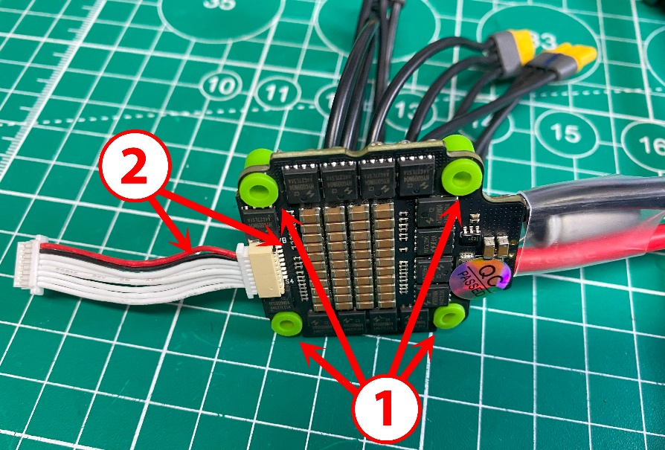 | ESC (Electronic Speed Controller)  1/ Install the damper rubber bumpers.  2/ Connect the cable. Observe the pinout. On the ESC board, pin VB (Voltage Battery) corresponds to the - red cable (+) on the loop.
 | 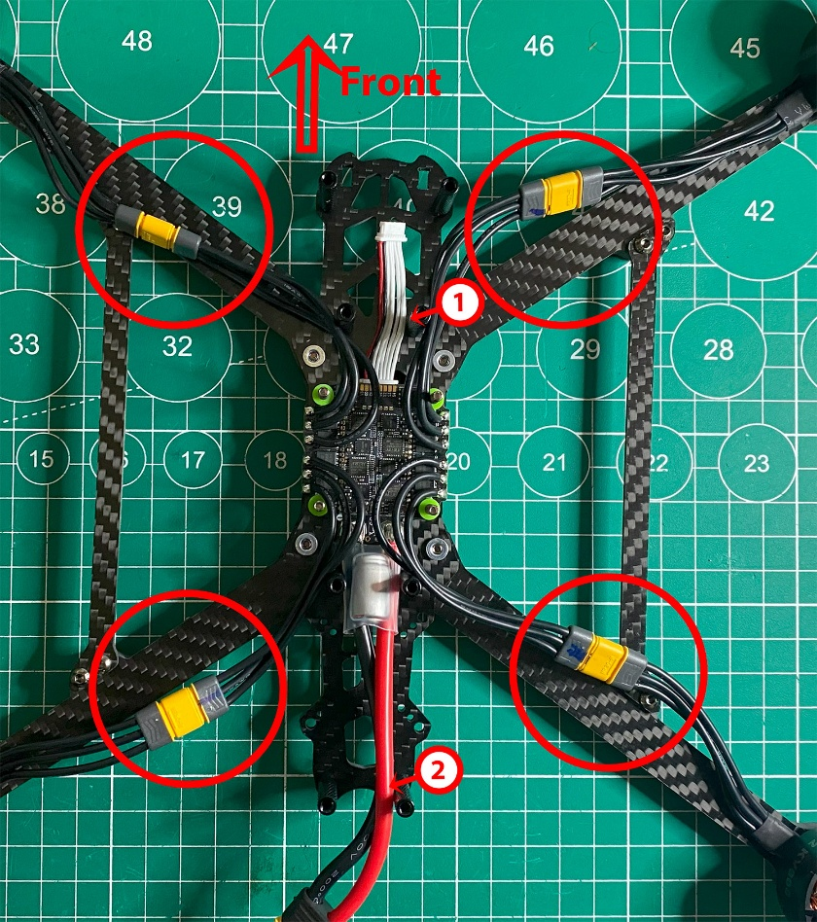 | Install the ESC on the frame.  Note where the front and rear of the frame are. The power cable (2) is directed to the rear and the loop (1) to the front.  Connecting all motors.
 | 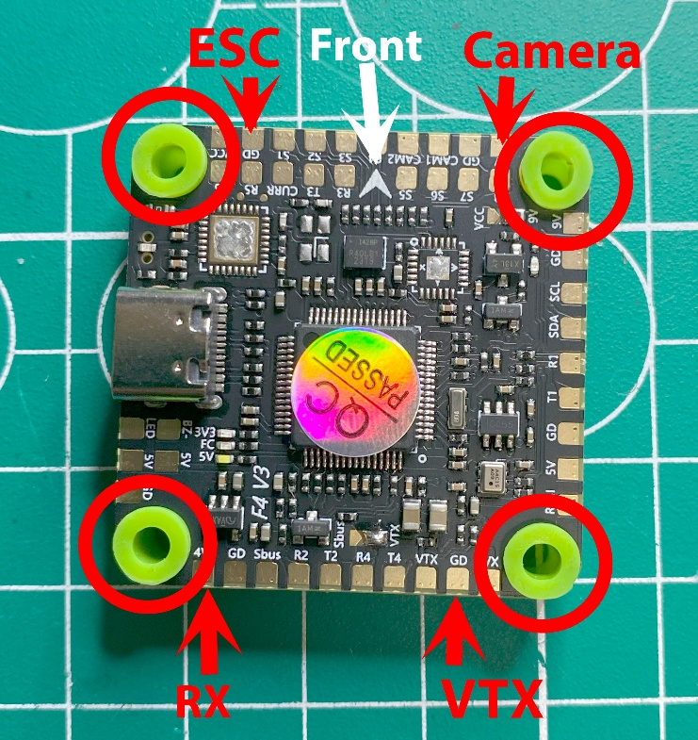 | FC (Flight Controller)  Installing the damper rubber bumpers on the FC
 | 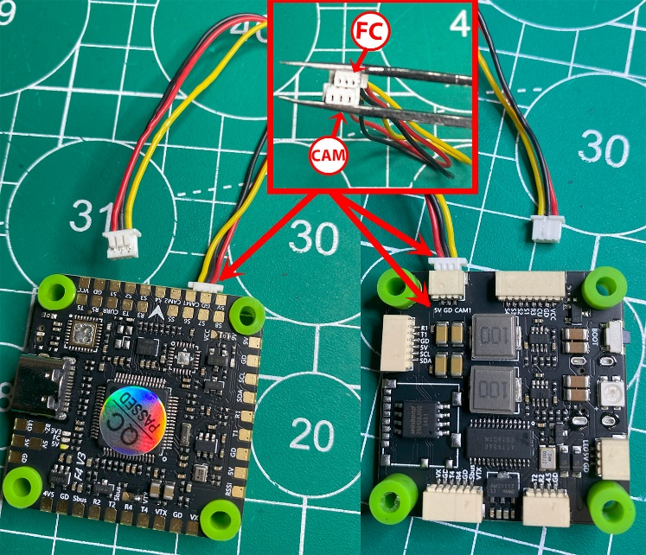 | Connect the camera cable to the FC. Take it from the stack kit.  The smaller 3 pin connector goes to the FC, the larger one goes to the camera.  Pay attention to the pinout.  The red wire on the cable goes to 5 volts on the board.
 | 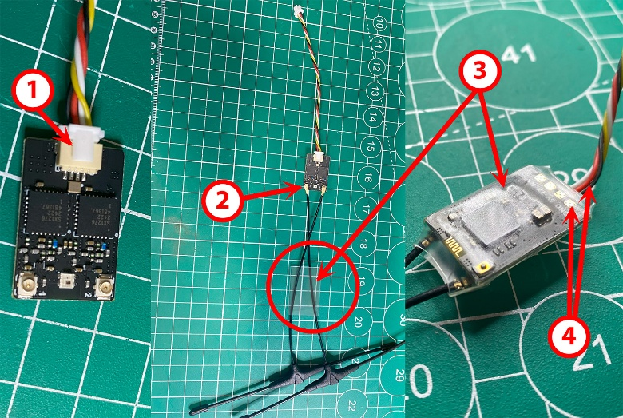  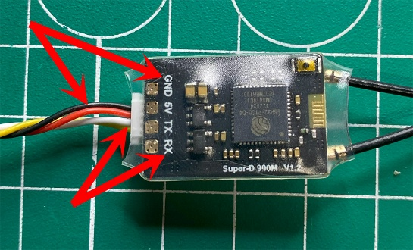 | RX sku 5202  1/ Connect the connector. Included RX . Pinout:  GND - Black cable (4)  - 5V-Red wire-  -RX- White  -TX- Yellow wire  2/ Put on antennas and heat shrink (3)  3/ Shrink the heat shrink with a hair dryer.
 | 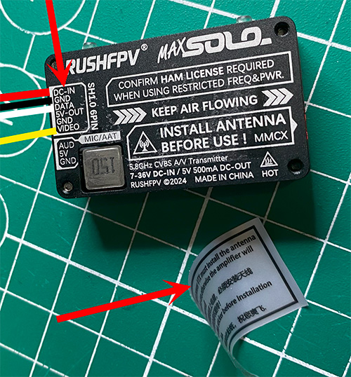 | VTX  Take off the sticker.  Please note the pinout on the VTX
 | 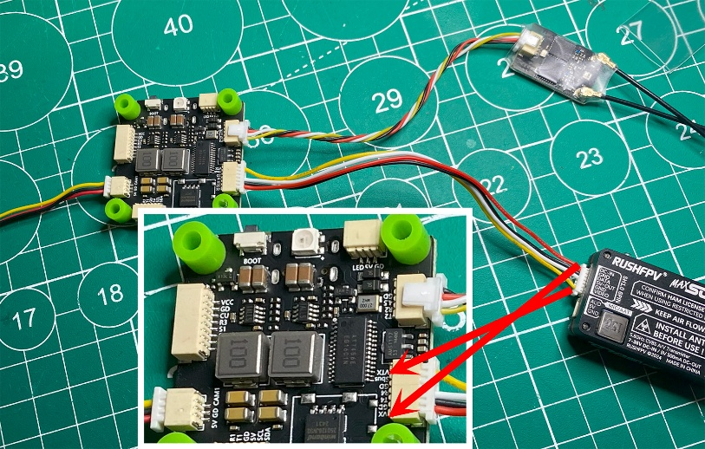  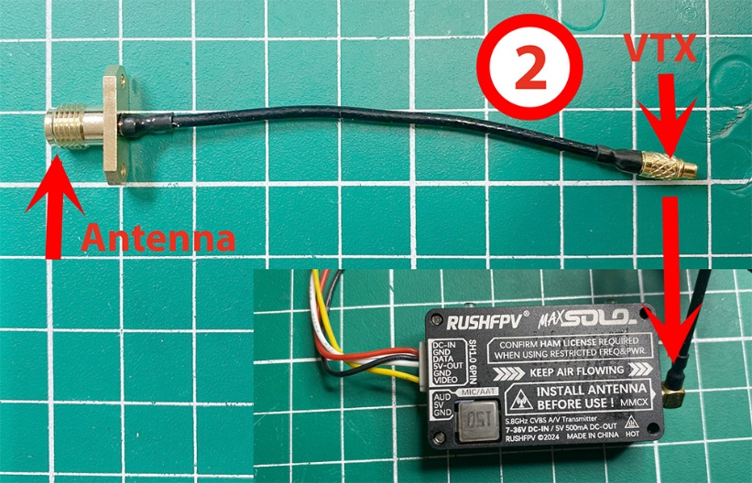 | Connect VTX and RX to FC  Pay attention to the pinout on the FC  - 5V-Red wire-  -GND- Black wire  -DATA- White  -VTX- Yellow wire  2/ Connect k VTX antenna cable- Pigtail until it clicks into place.  Cable included VTX
 | 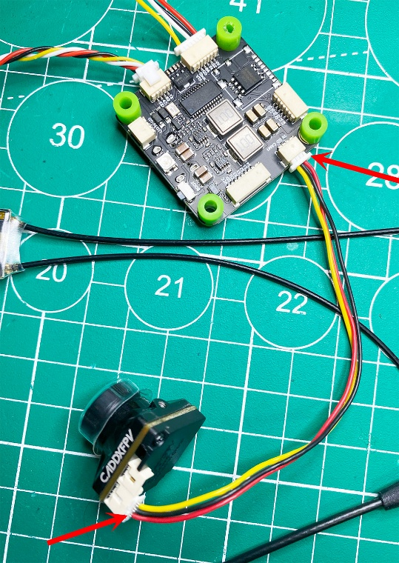 | Connect the camera. Check the pinout.  - 5V-Red wire-  -GND- Black wire  -CAM- Yellow wire
 | 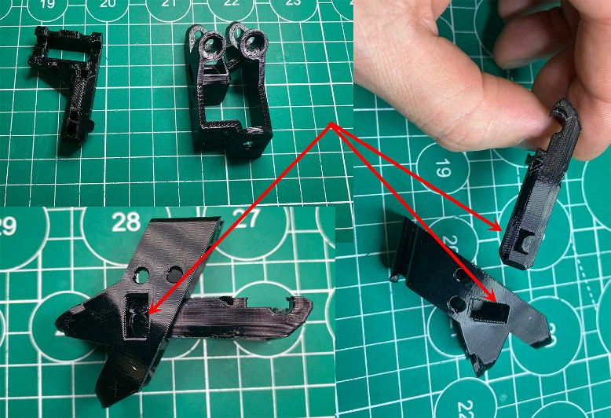 | Connect the antenna holder which consists of two parts.  The ledge should be in the cutout for it.
 | 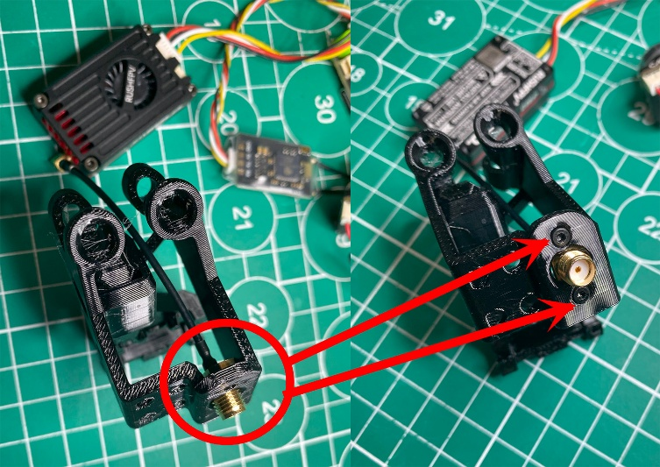 | Inserting Pigtail  into the antenna holder and fasten it with two m2 3mm bolts
 | 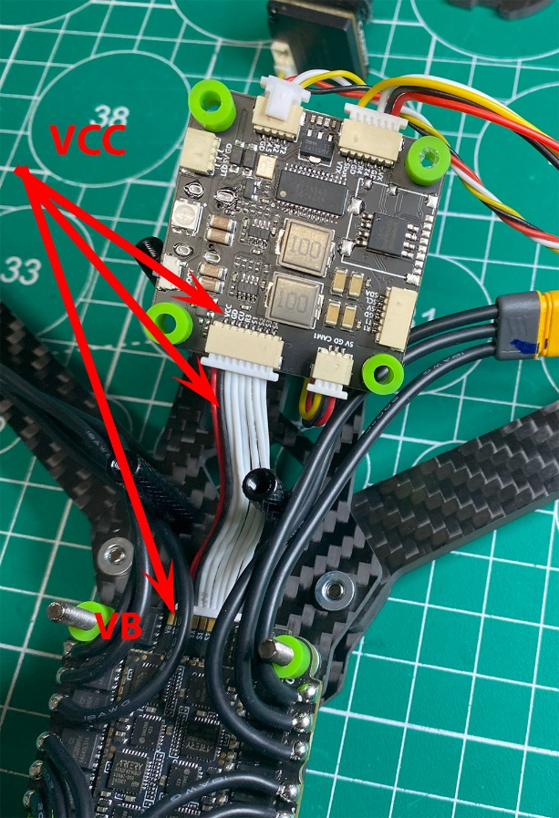 | Connect the FC to the ESC using the cable from the stack kit.  Let's check the layout.  Red wire from VB on ESC to VCC on FC.  It is necessary to check the pinout of the whole loop if the components used are not from the same set.
 | 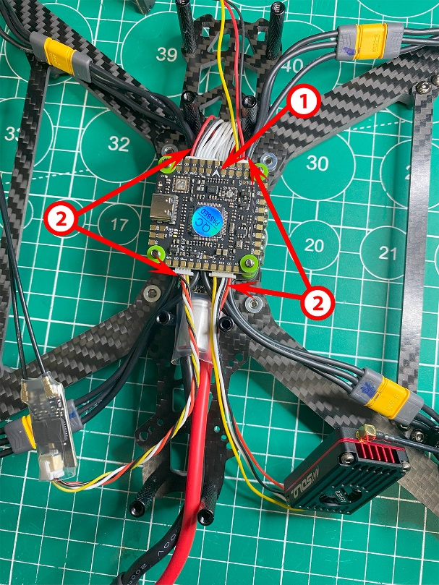 | Set FC.  1/ the arrow points to the front of the drone.  2/ Visually look at the connectors. Usually the power cables (red and black) are located at the edges/corner of the board.
 | 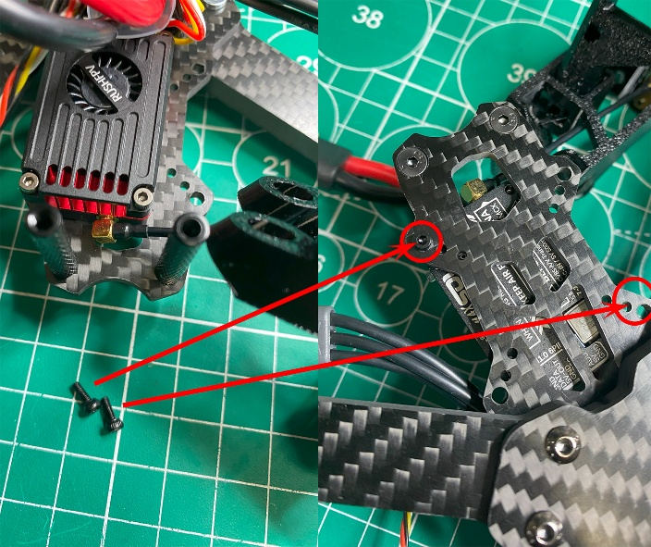 | Screw the VTX to the frame.  Bolts m2x5mm.
 | 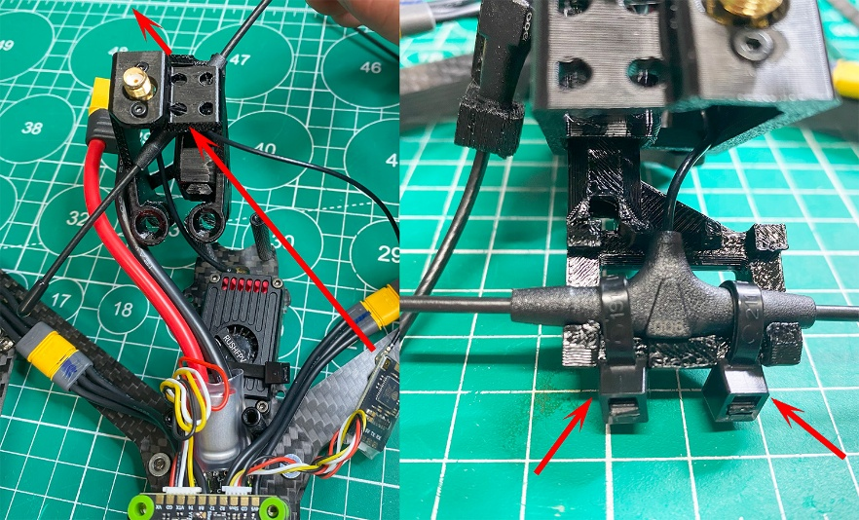  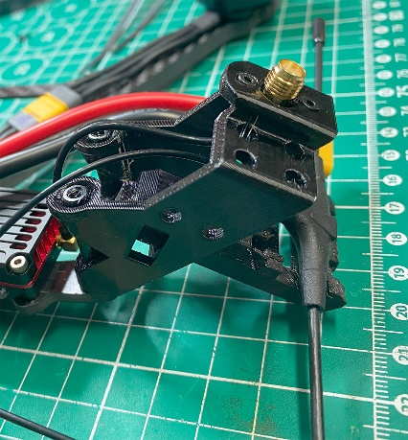 | Lead one of the RX Diversity antennas into the antenna holder. And secure with zip  Install the antenna holder on the frame.
 | 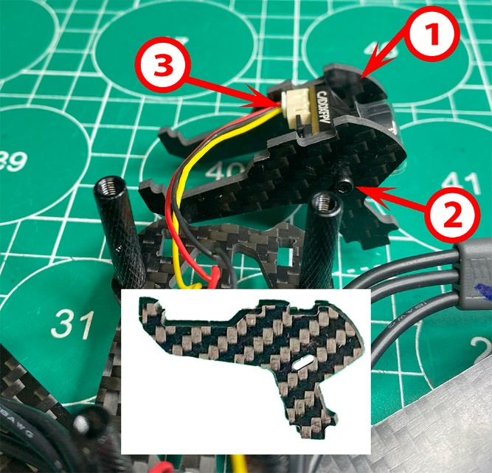 | 1/ Attach the camera to the camera holders in the frame kit.  2/ Fasten with two M2x5mm bolts at an inclination of 30 degrees.  3/ red power cable on the left edge of the camera when viewed from the top of the camera
 | 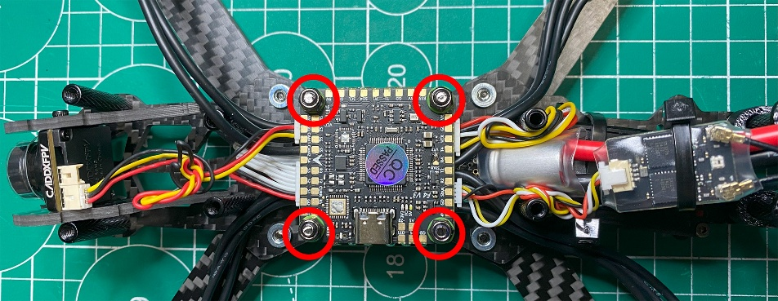  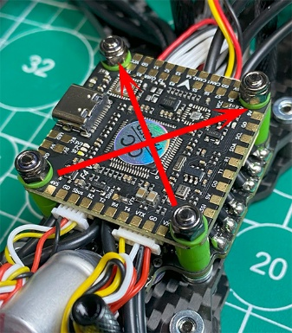 | Stack Tighten with rubberized m3x nuts.  Tighten aslant.  The bolt should come out a few turns. The damping rubber should not pop out and should not be too tight.
 | 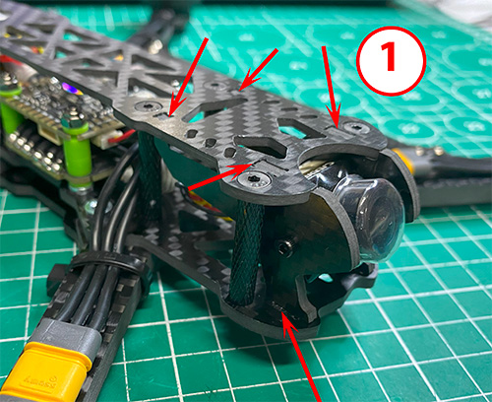  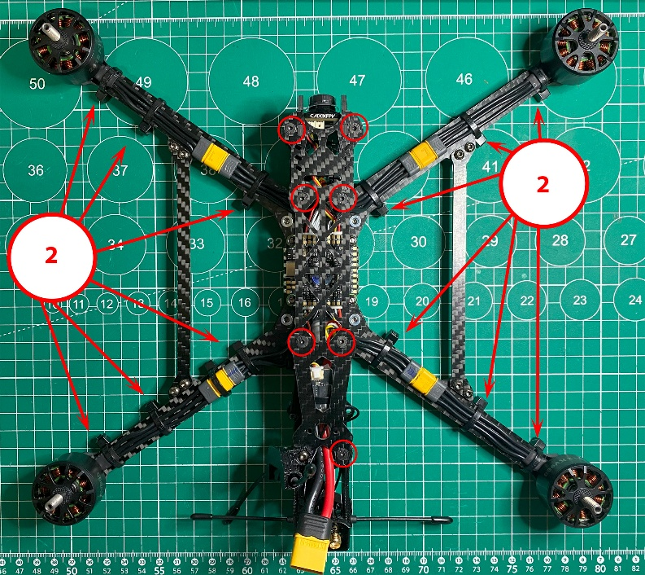 | 1/ Put on the top cover of the drone. Make sure that the tabs on the camera mounts fit into the grooves of the top and bottom cover.  2/ Screw in the M3x8mm bolts with recessed flats  Attach the wires from the motors to the beams using wire ties.
 | 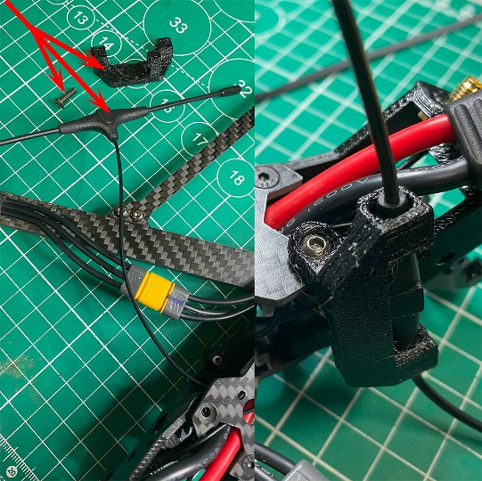 | Install and fasten the holder for the second RX antenna to the frame in the left rear corner using a M3x10mm bolt
 | 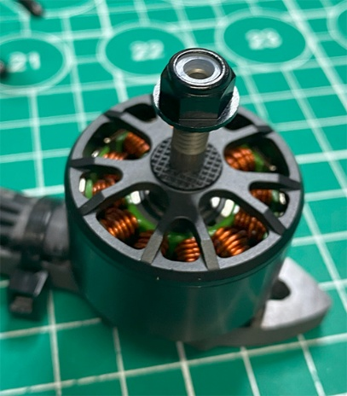 | Tighten all the bolts on the frame top and bottom, on the motors.  Screw on the propeller mounting nut.

A photo of the finished drone:
Top view:
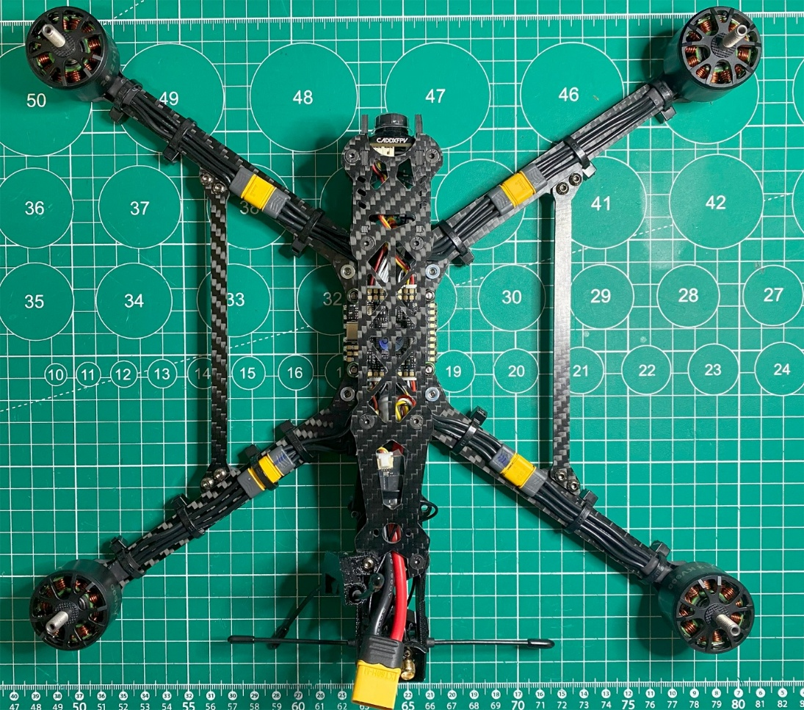
Bottom view:
