Assembling the Mark4-8 V2 Partizan Edition Frame sku 6422
Equipment:
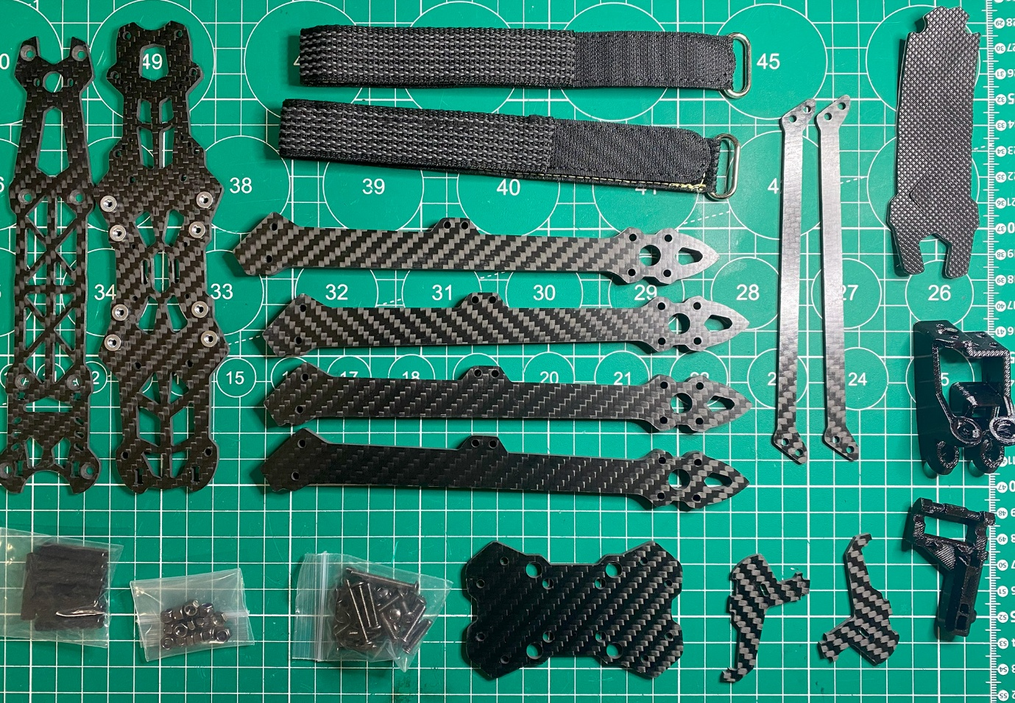

N | Photo | Quantity
1 | 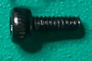 | M2x5mm  -2 pcs.
2 | 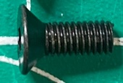 | M3x8mm  -12 pcs.
3 | 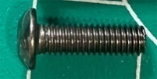 | M3x10mm  -4 pcs
4 | 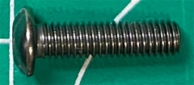 | M3x12mm  -8 pcs.
5 | 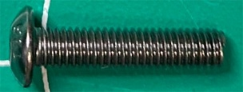 | M3x14mm  -4 pcs
6 | 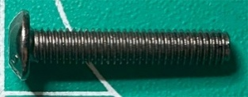 | M3x16mm  -4 pcs
7 | 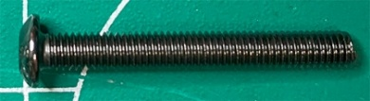 | M3x25mm  -4 pcs
8 | 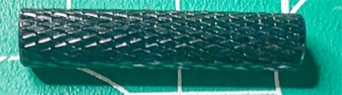 | 25mm  -8 pcs.
9 | 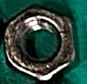 | M3 nut  -4pcs
10 | 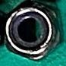 | M3 nut with rubber band  -12pcs
11 | 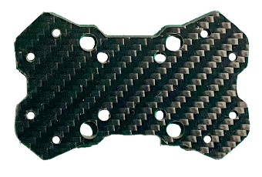 | Beam Mounting Board  -1pc
12 | 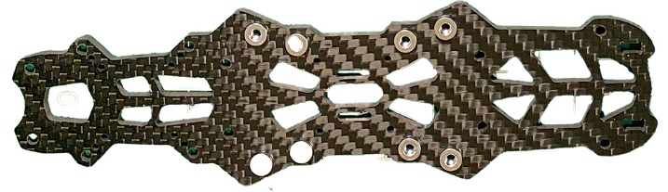 | Bottom board  -1pc
13 | 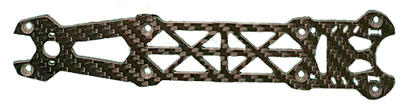 | Top board  -1pc
14 | 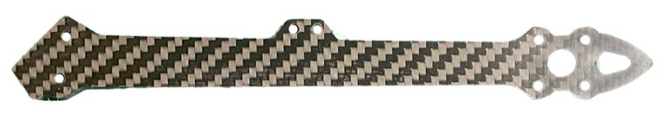 | Rays  -4pcs
15 | 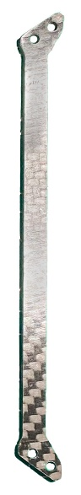 | Jumper to the beams  -2pc
16 | 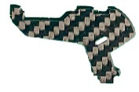 | Camera mount  -2pc
17 | 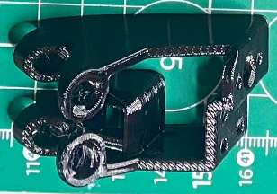 | Plastic antenna holder VTX  -1pc
18 | 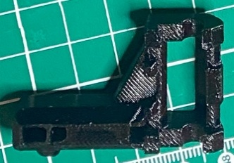 | Plastic RX antenna holder  -1pc
19 | 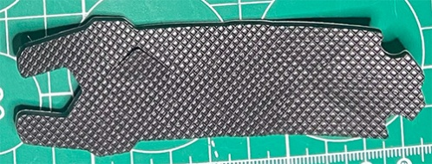 | Battery rubber band  -1pc
20 | 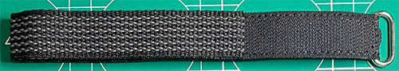 | Strap for securing the battery  -2pc

CONSTRUCTION:

Frame assembly

 | 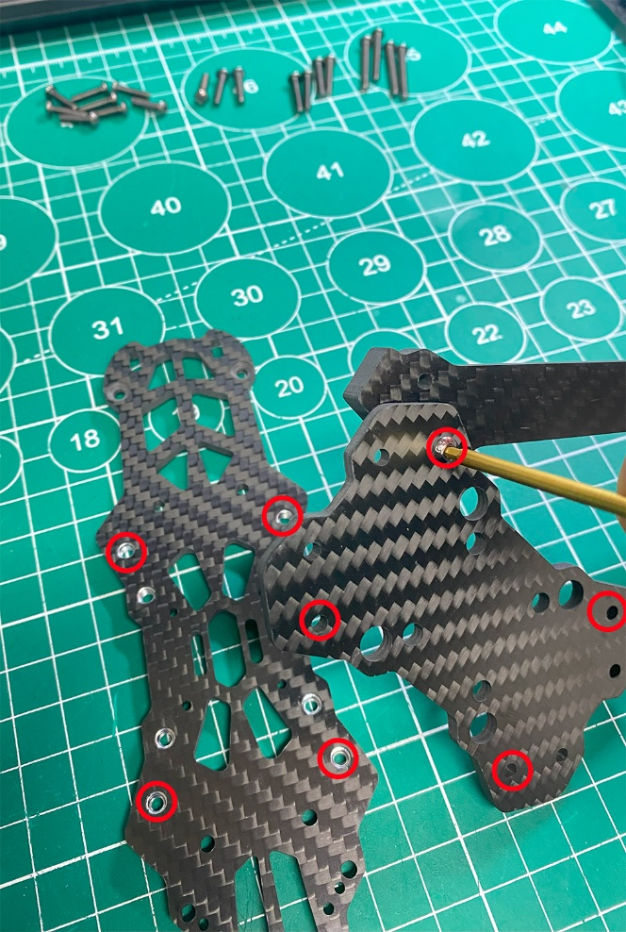  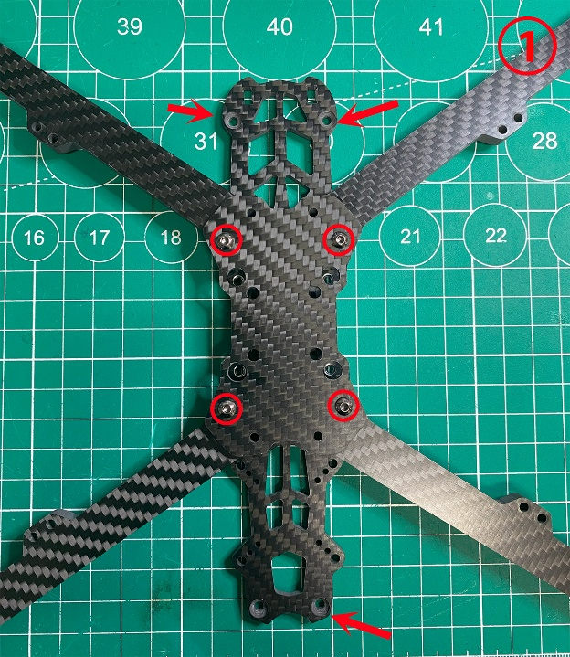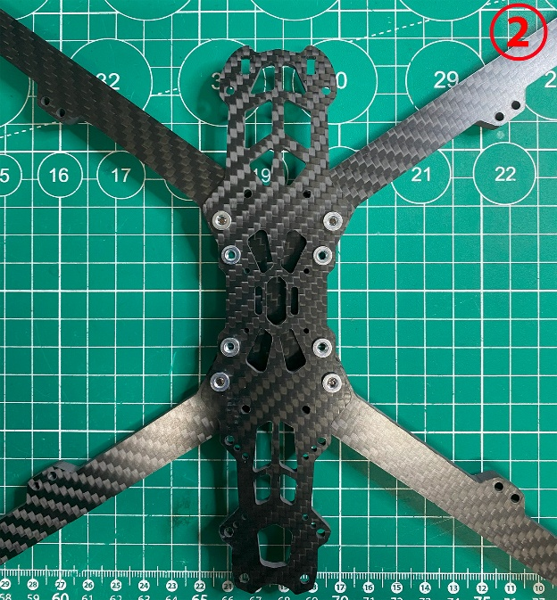 | Sorting out the largest bolts.  Secure the rays.  Details:  5+11+12+14  Use M3x14mm bolts to fasten the beams between the bottom board and the board to secure the beams  Picture 1: Bottom view.  The arrows indicate the position of the part to be observed  Picture 2: Top view
 | 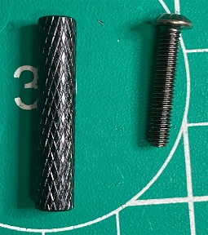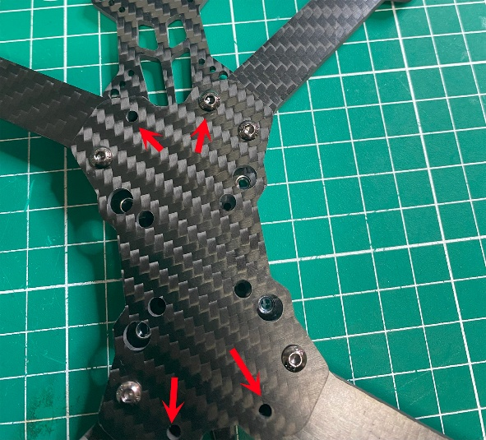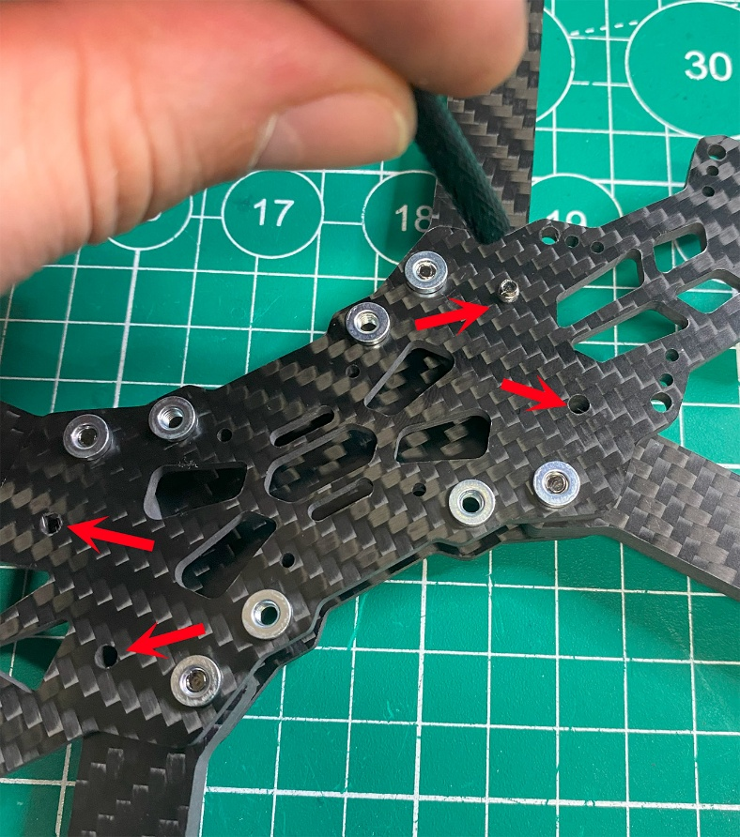 | Detail 4- bolt M3x16mm  -4 pcs  Detail 8 - rack M3x25mm  -4 pcs  Align the beams so that the bolt holes converge. Bolt the beams to the posts.
 | 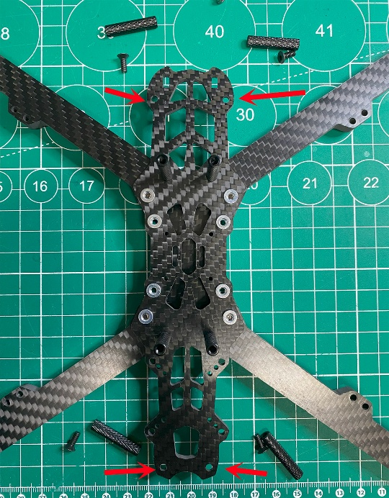  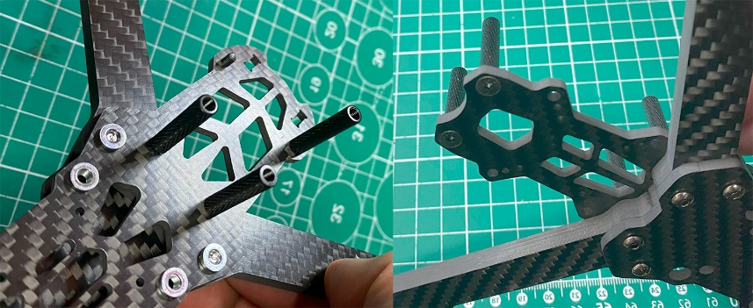 | Detail 2- M3x8mm  -4  Detail 8 - rack M3x25mm  -4 pcs  1/ Install the remaining 4 posts on the lower enclosure board. Insert the bolt caps into the recesses.
 | 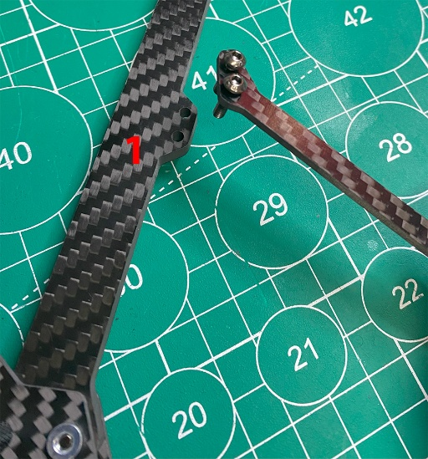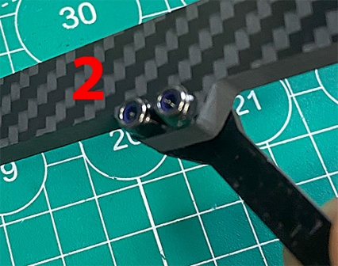  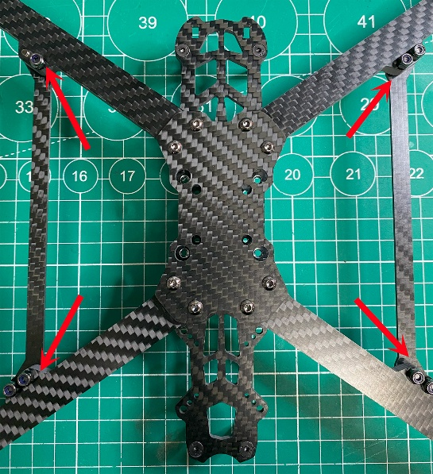 | Detail 4- Bolt M3x12mm  -8pcs  Detail 15-Crosspiece -2p  Detail 10 - M3 nut with rubber band  -8pcs  Jumpers are placed on top of the beams.  1 / Set the Jumpers on the beams.  2/ tighten with nuts with locking rubber band
 | 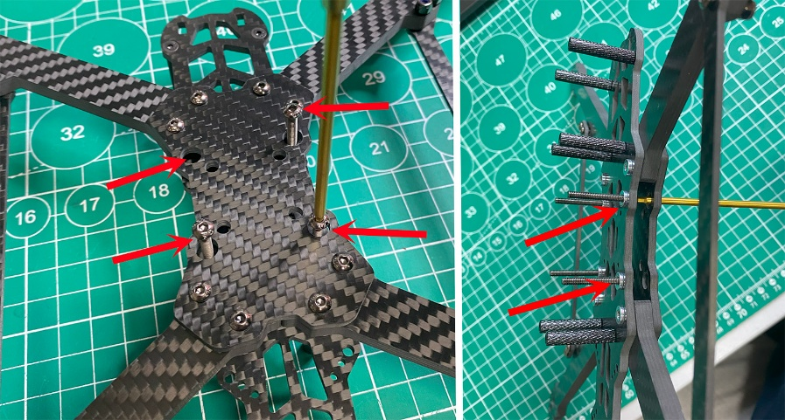 | Detail 7 - Bolt M3x25mm  -4 pcs  Screw in and tighten the bolts to secure the stack.
 | 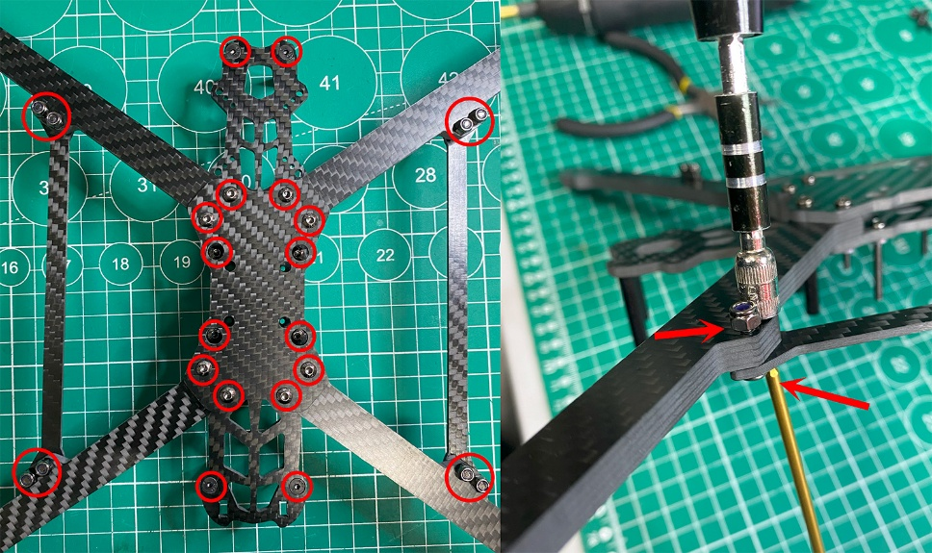  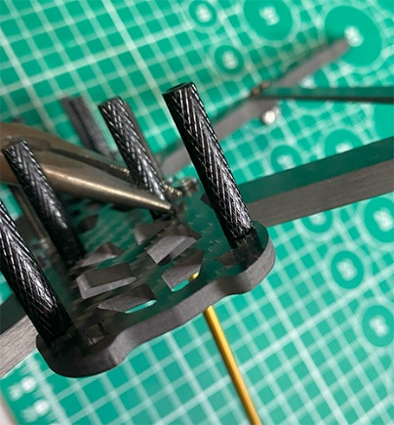 | Tighten all Bolts, Stays, Nuts.  Hold the bolts with a screwdriver and tighten the nut with a 5.5 wrench.  Holding the rack firmly with pliers, tighten its bolt.

